impactfitnesswrga@yahoo.com

**HOME**

* ~~24 hour access~~
* ~~Free nutritional information from trainers and weekly newsletter~~.

**ABOUT**

* Rates, first session free
* Schedule
* ~~Instructors are available during business hours to provide personal attention and teach, motivate, and assist with workouts to ensure safety and correct workout execution.~~
* ~~Weekly weigh-ins and measurements for motivation and accountability~~
* ~~Google Maps~~
* 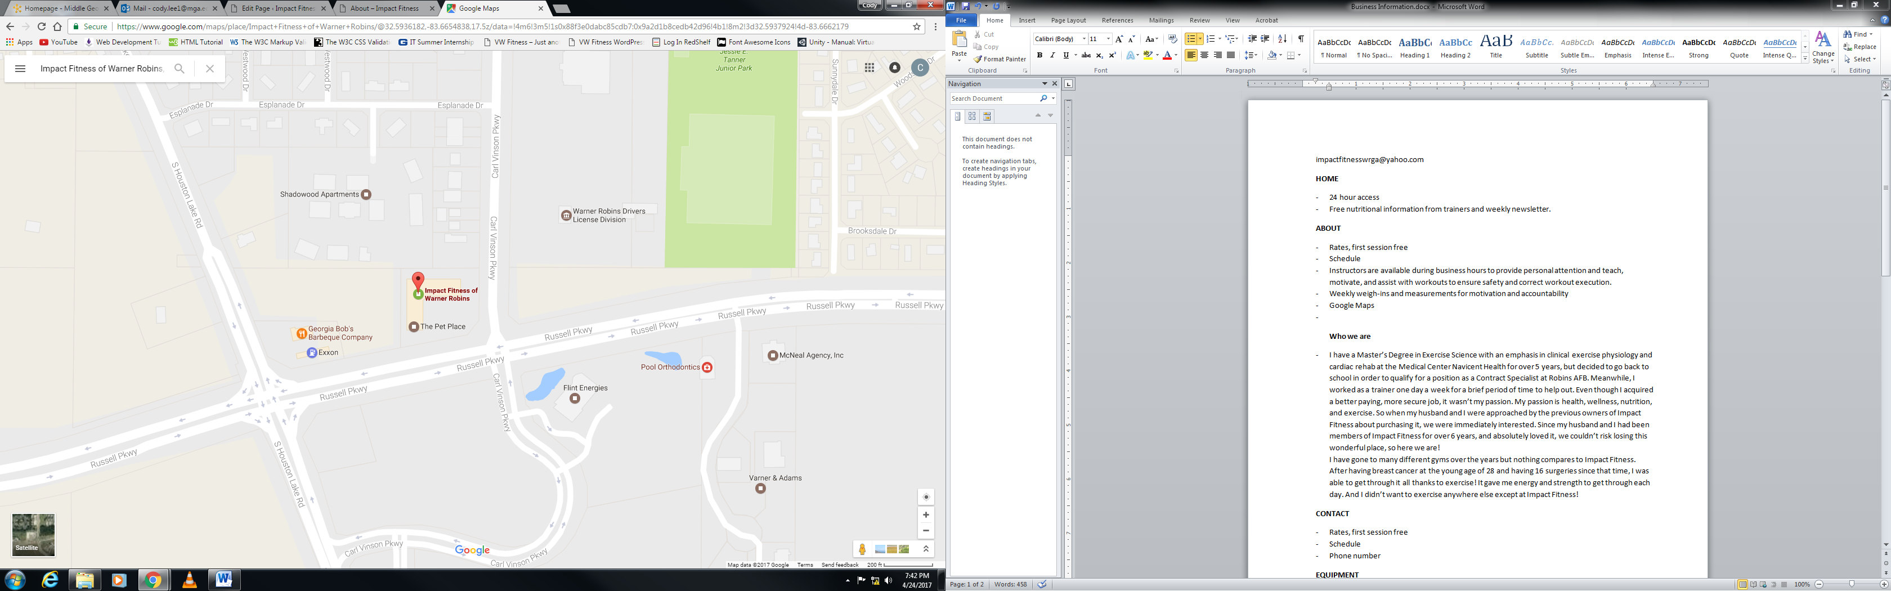

**Who we are**

* ~~I have a Master’s Degree in Exercise Science with an emphasis in clinical exercise physiology and cardiac rehab at the Medical Center Navicent Health for over 5 years, but decided to go back to school in order to qualify for a position as a Contract Specialist at Robins AFB. Meanwhile, I worked as a trainer one day a week for a brief period of time to help out. Even though I acquired a better paying, more secure job, it wasn’t my passion. My passion is health, wellness, nutrition, and exercise. So when my husband and I were approached by the previous owners of Impact Fitness about purchasing it, we were immediately interested. Since my husband and I had been members of Impact Fitness for over 6 years, and absolutely loved it, we couldn’t risk losing this wonderful place, so here we are!~~

~~I have gone to many different gyms over the years but nothing compares to Impact Fitness. After having breast cancer at the young age of 28 and having 16 surgeries since that time, I was able to get through it all thanks to exercise! It gave me energy and strength to get through each day. And I didn’t want to exercise anywhere else except at Impact Fitness!~~

* Bryan

**CONTACT**

* Rates, first session free
* Schedule
* Phone number

**EQUIPMENT**

* ~~We incorporate calisthenics, plyometrics, weight training, kick boxing, core training, balance and coordination into all workouts~~ (pics)
* ~~Top of the line weight-machines~~ (pics)

**WORKOUTS**

~~Our workouts involve high-intensity interval training (HIIT) that focuses on all areas of the body. HIIT is a type of physical exercise characterized by brief, intermittent bursts of rigorous activity, interspersed by periods of rest or low-intensity exercise. Growing evidence suggests that this form of training stimulates physiological improvements comparable to continuous, moderate-intensity training, despite a substantially lower time commitment and reduced total exercise volume. What this means is that HIIT training gets you the same physiological results as continuous, moderate-intensity training but you get those same results in a shorter period of time by doing fewer exercises.~~

* ~~We are about getting results without having to spend hours in a boring gym!~~
* ~~All workouts are created by certified trainers and change every week so you never get bored and your body is always challenged to get stronger.~~

**TESTEMONIALS**

* Testimonials; before and after pics